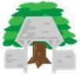
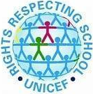
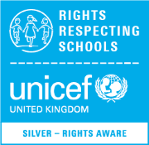
Lydgate Junior School
Curriculum Progression for PSHE

At Lydgate Junior School, we know how to look after and respect ourselves and others.
Core Themes
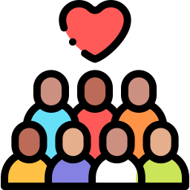 | Communities | 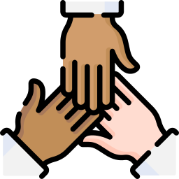 | Relationships | 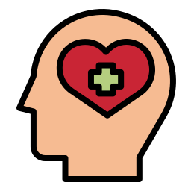 | Mental Well-being | 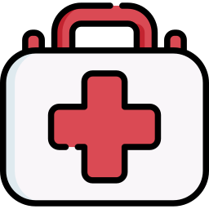 | Health
Curriculum Overview
 | Year 3 | Year 4 | Year 5 | Year 6
Autumn 1 | Physical Health  How do I keep my body healthy?  How do I get a healthy diet? | Mental Health  Recap Zones of Regulation  Our Communities  How do we make the world fair? | Relationships  What makes a close friend?  Can we be different and still be friends?  Mental Health  Recap Zones of Regulation | Relationships  What are stereotypes?  Physical Health  Where do I get my information from?  Mental Health  Recap Zones of Regulation
Autumn 2 | Mental Health  The Zones of Regulation | Relationships  Are all friends the same?  Are friendships always fun? | Relationships  Why do some people get married?  Our Communities  How can I be a great citizen? | Our Communities  What is prejudice?  What is the history of prejudice?  What should I do if I encounter prejudice?
Spring 1 | Mental Health  How do I manage my feelings?  Online Safety  Strangers and Sharing Online | Mental Health  Are we happy all the time?  Online Safety  Friendships online and Personal information | Relationships  Should friends tell us what to do?  Why are some people unkind?  Online Safety  Control and consent, Protecting identity, Meeting strangers, personal information, terms and conditions. | Relationships  Are families ever perfect?  Is there such a thing as a normal family?  Physical Health  How do I save a life?  Online Safety  Analysing digital media and bias.
Spring 2 | Online Safety  Digital Media  Relationships  Do families always stay the same?  What makes a good friend? | Our Communities  How can we help the people around us? | Mental Health  Does everybody have the same feelings?  Should we be happy all the time? | Mental Health  Why do we argue?  Who am I?  Relationships  How do I accept my friends for who they are?
Summer 1 | Our Communities  How do we make the world fair?  Where do you feel like you belong? | Physical Health  How do I stop getting ill? | Our Communities  Why is money important?  How should I spend my money?  How can I earn money?  Physical Health  Is there such a thing as the perfect body?  How can I stay fit and healthy? | Our Communities  What makes us feel like we belong?  What does it mean to be British?  Physical Health  How will my feelings change as I get older?
Summer 2 |  | Relationships  How should we treat people who are different?  Are all families like mine? | Physical Health  How will my body change as I get older?  What is menstruation? | Physical Health  Can I avoid getting ill?  Why do some people take drugs?  How do plants and animals reproduce?  How are babies made? (non stat)

At Lydgate Junior School we follow the Learn Sheffield scheme for RHE within PSHE. We ensure that this also covers the elements of British values and citizenship. As individual teachers (or if required as a staff) we ensure we are responsive to moments of significance in the news around the world. We also adapt our planning and lessons in accordance with relevant issues for pupils at our school or in our individual classes.

